\begin{table} \definecolor{primary}{HTML}{0DA2CC} \definecolor{secondary}{HTML}{6EB819} \definecolor{tertiary}{HTML}{FD602E} \definecolor{gray}{HTML}{4C4F54} \definecolor{medium_gray}{HTML}{7F7F7F} \arrayrulecolor{gray}

▲

\begin{tabular}{|c|c|}\hline {\cellcolor{medium_gray}}

\textcolor{white}{$x$}&{\cellcolor{primary}}

\textcolor{white}{$f(x)=x+1$}\\\hline{\cellcolor{white}}

\textcolor{gray}{$-3$}&{\cellcolor{white}}

\textcolor{gray}{$-2$}\\\hline{\cellcolor{white}}

\textcolor{gray}{$-2$}&{\cellcolor{white}}

\textcolor{gray}{$-1$}\\\hline{\cellcolor{white}}

\textcolor{gray}{$-1$}&{\cellcolor{white}}

\textcolor{gray}{$0$}\\\hline{\cellcolor{white}}

\textcolor{gray}{$0$}&{\cellcolor{white}}

\textcolor{gray}{$1$}\\\hline{\cellcolor{white}}

\textcolor{gray}{$1$}&{\cellcolor{white}}

\textcolor{gray}{$2$}\\\hline{\cellcolor{white}}

\textcolor{gray}{$2$}&{\cellcolor{white}}

\textcolor{gray}{$3$}\\\hline{\cellcolor{white}}

\textcolor{gray}{$3$}&{\cellcolor{white}}

\textcolor{gray}{$4$}\\\hline  
  
  
\end{tabular} \end{table}

Given function is f(x)=\frac{x^{2}-1}{x-1}. Put given denominator equal to zero. We will have:

Solver

Top of Form

Input

Solve

Solution



Bottom of Form

At x=1. The given function is undefined as shown:

Solver

Top of Form

Input

Solve

Solution



Bottom of Form

So simplifying the expression.

Solver

Top of Form

Input

Solve

Solution



Bottom of Form

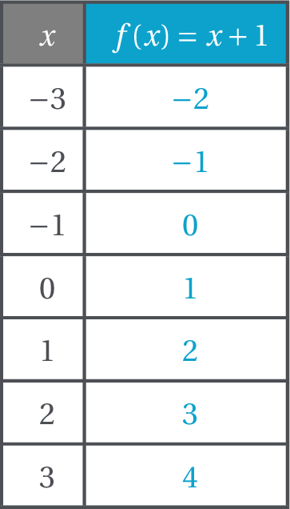

Use given values of x to generate get values of f(x)=x+1 and x\ne1.

Use given points to sketch the graph of the given function given that f(x)=x+1 and x\ne1.

Plot undefined point as shown.

Plot all the remaining points for given values as in step 4.

Join all the points with the line with the break at (1,2).

The graph of the line function f(x) and x\ne1 with the break at (1,2).